У BigQuery я побудувала pipeline з двох етапів. На першому етапі виконала Data Cleaning: аналіз пропусків, перевірку дублікатів, виявлення пошкоджених значень через SAFE_CAST(), очищення даних та створення нової ознаки price_per_m2. На другому етапі виконала Exploratory Data Analysis для виявлення факторів, що впливають на вартість квартир у Польщі.
Data Cleaning
1. Створення чистої таблиці
CREATE OR REPLACE TABLE `apartment-prices-in-poland.prices.apartments_clean` AS
SELECT *
FROM `apartment-prices-in-poland.prices.apartments_pl_2023`;
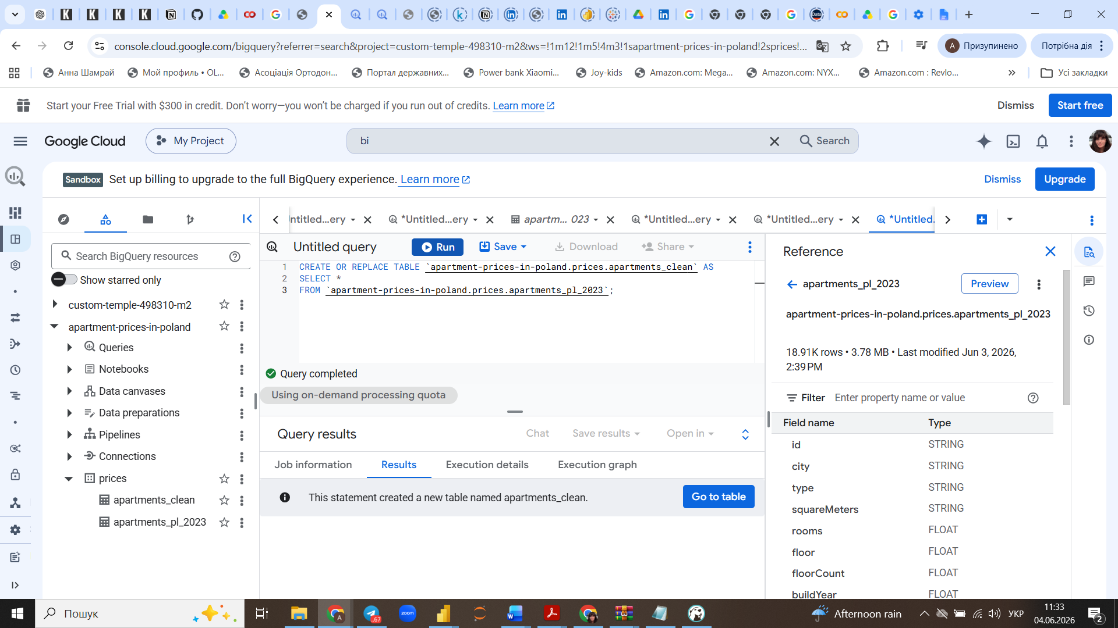

2. Data Quality — пропуски (NULL analysis)
SELECT
COUNT(*) AS total_rows,
COUNTIF(price IS NULL) AS price_nulls,
COUNTIF(squareMeters IS NULL) AS square_nulls,
COUNTIF(rooms IS NULL) AS rooms_nulls,
COUNTIF(buildYear IS NULL) AS buildYear_nulls,
COUNTIF(type IS NULL) AS type_nulls,
COUNTIF(buildingMaterial IS NULL) AS material_nulls,
COUNTIF(condition IS NULL) AS condition_nulls
FROM `apartment-prices-in-poland.prices.apartments_clean`;
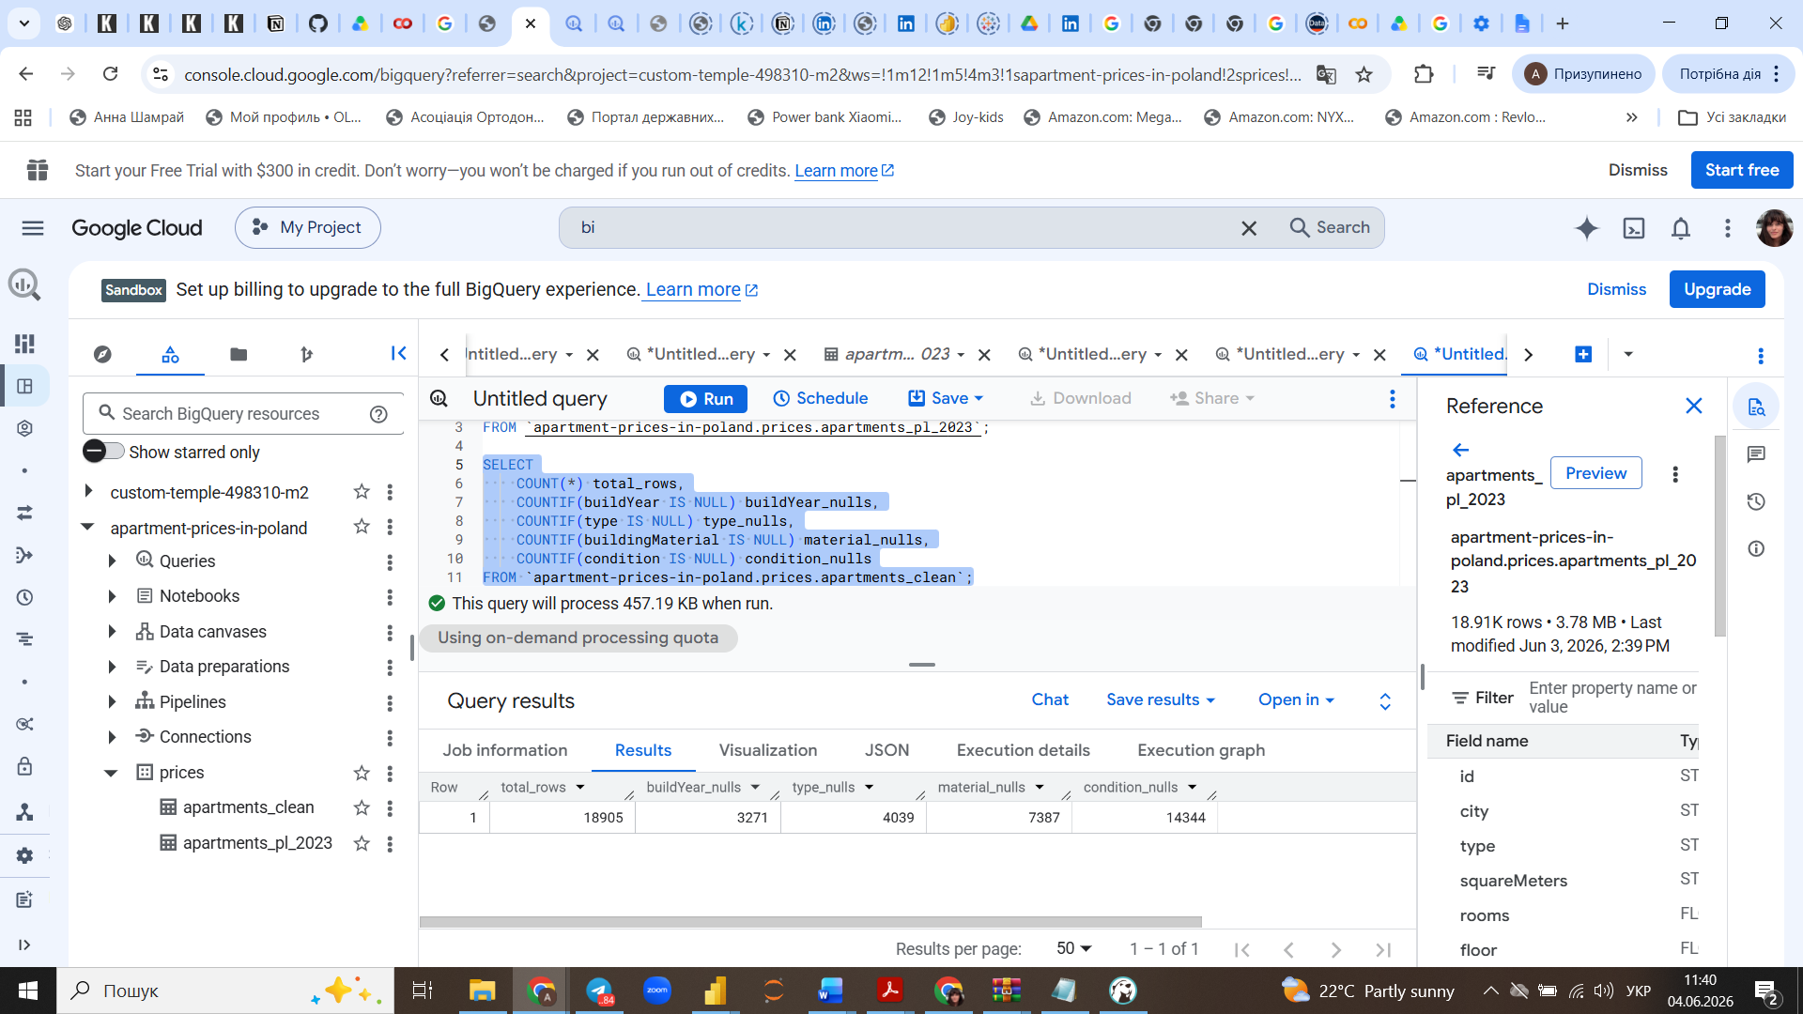

3. Перевірка дублікатів
SELECT
COUNT(*) AS total_rows,
COUNT(DISTINCT id) AS unique_ids
FROM `apartment-prices-in-poland.prices.apartments_clean`;
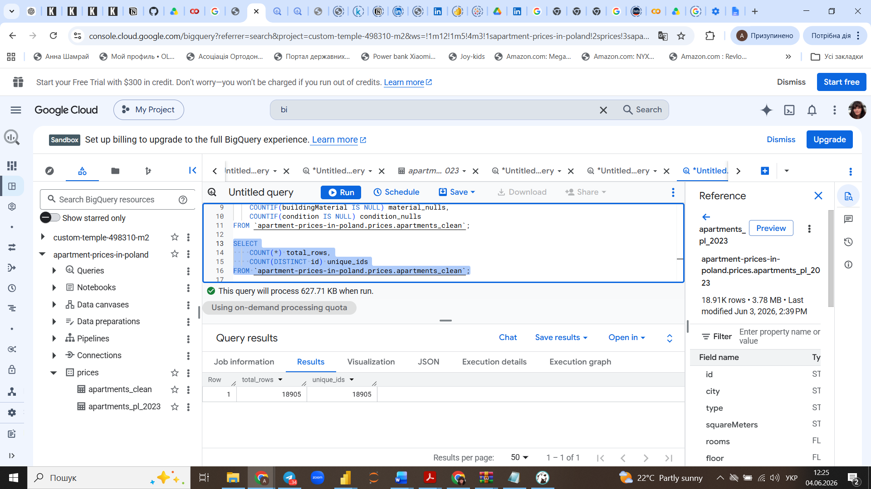

4. Базова статистика (outliers check)
SELECT
MIN(price) AS min_price,
MAX(price) AS max_price,
MIN(squareMeters) AS min_area,
MAX(squareMeters) AS max_area,
MIN(rooms) AS min_rooms,
MAX(rooms) AS max_rooms
FROM `apartment-prices-in-poland.prices.apartments_clean`;
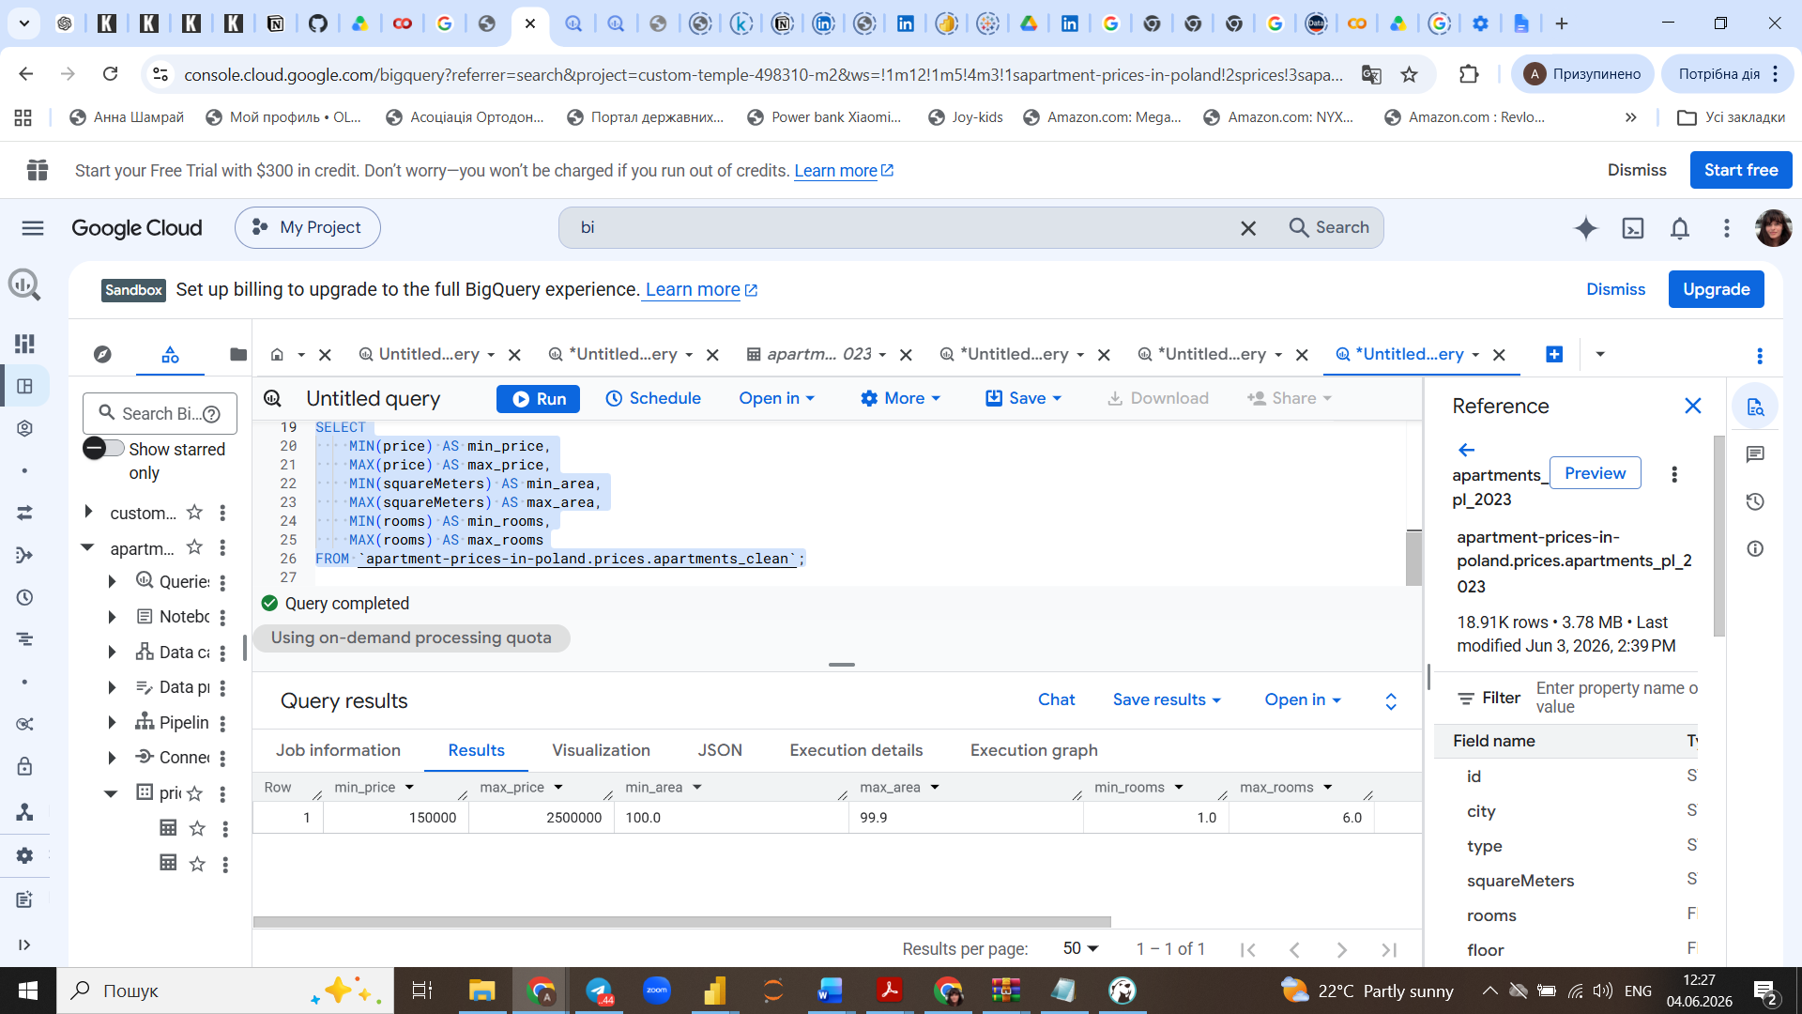
5. Перевірка коректності числових значень
SELECT
COUNT(*) AS total_rows,
COUNT(SAFE_CAST(squareMeters AS FLOAT64)) AS valid_area
FROM `apartment-prices-in-poland.prices.apartments_clean`;
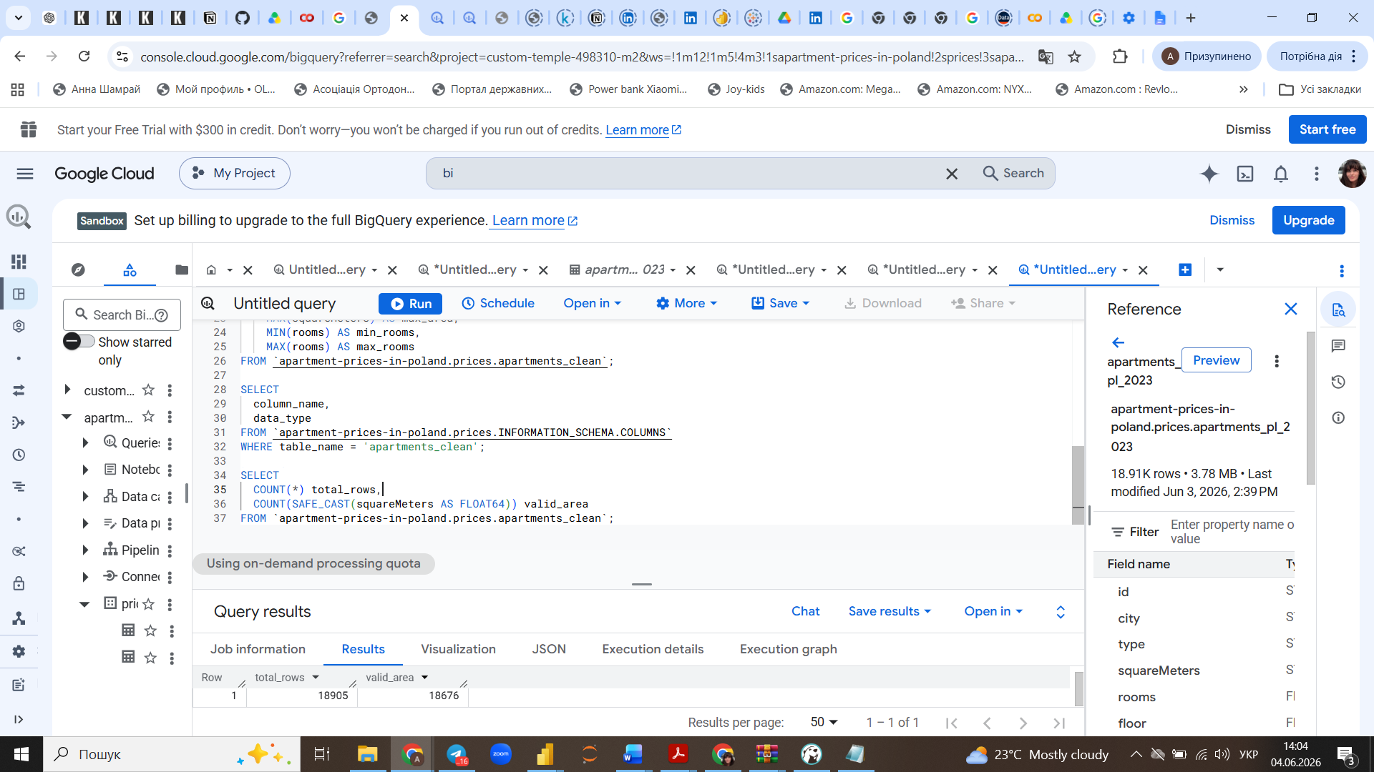

6. Створення фінальної таблиці (очищення)
CREATE OR REPLACE TABLE `apartment-prices-in-poland.prices.apartments_final` AS
SELECT *
FROM `apartment-prices-in-poland.prices.apartments_clean`
WHERE SAFE_CAST(squareMeters AS FLOAT64) IS NOT NULL;
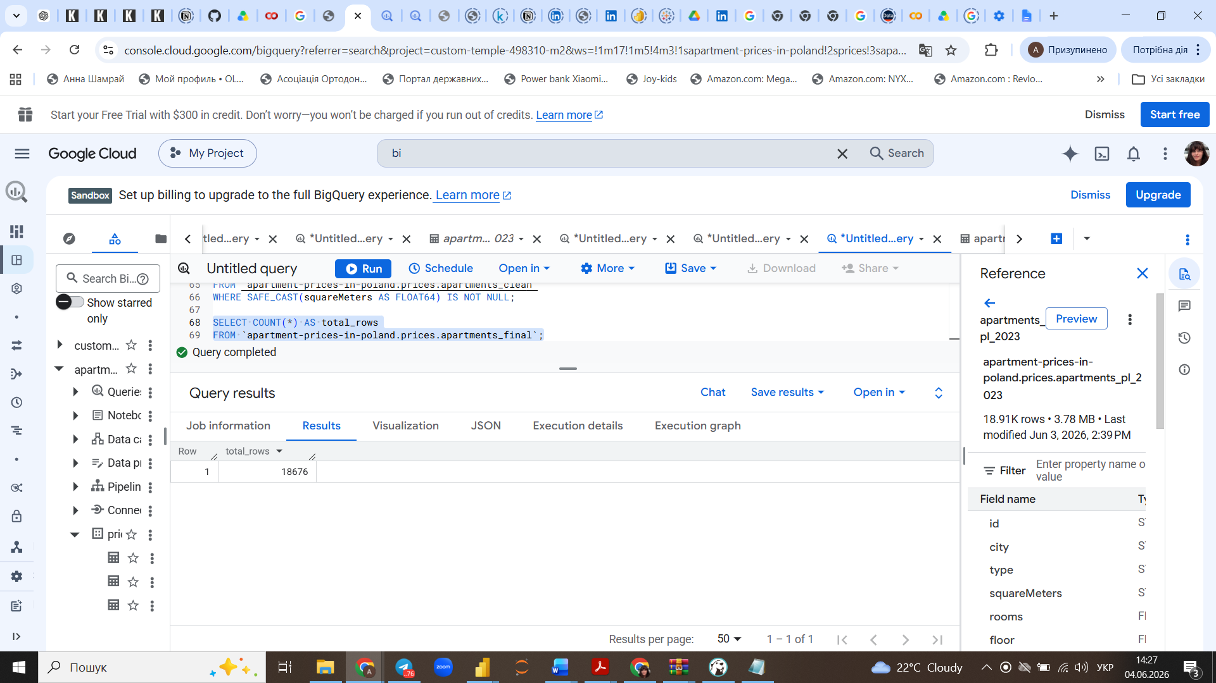

7. Feature engineering (price per m²)
CREATE OR REPLACE TABLE `apartment-prices-in-poland.prices.apartments_final` AS
SELECT *,
price / SAFE_CAST(squareMeters AS FLOAT64) AS price_per_m2
FROM `apartment-prices-in-poland.prices.apartments_clean`
WHERE SAFE_CAST(squareMeters AS FLOAT64) IS NOT NULL;
EDA (Exploratory Data Analysis)
8. Середня ціна по містах
SELECT
city,
ROUND(AVG(price),0) AS avg_price
FROM `apartment-prices-in-poland.prices.apartments_final`
GROUP BY city
ORDER BY avg_price DESC;

9. Середня ціна за м² по містах
SELECT
city,
ROUND(AVG(price_per_m2), 0) AS avg_price_per_m2
FROM `apartment-prices-in-poland.prices.apartments_final`
GROUP BY city
ORDER BY avg_price_per_m2 DESC;

10. Вплив кількості кімнат
SELECT
rooms,
COUNT(*) AS apartments,
ROUND(AVG(price), 0) AS avg_price,
ROUND(AVG(price_per_m2), 0) AS avg_price_m2
FROM `apartment-prices-in-poland.prices.apartments_final`
GROUP BY rooms
ORDER BY rooms;

11. Нові vs старі будинки
SELECT
CASE
WHEN buildYear >= 2010 THEN 'New'
ELSE 'Old'
END AS building_age,
COUNT(*) AS apartments,
ROUND(AVG(price), 0) AS avg_price,
ROUND(AVG(price_per_m2), 0) AS avg_price_m2
FROM `apartment-prices-in-poland.prices.apartments_final`
WHERE buildYear IS NOT NULL
GROUP BY building_age;

12. Вплив паркінгу
SELECT
hasParkingSpace,
COUNT(*) AS apartments,
ROUND(AVG(price), 0) AS avg_price,
ROUND(AVG(price_per_m2), 0) AS avg_price_m2
FROM `apartment-prices-in-poland.prices.apartments_final`
GROUP BY hasParkingSpace;

